How To Enroll Guide

- Navigate to website - www.beenleightheatregroup.com/jets
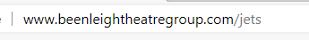
- Select ‘Enroll/Pay Now’
This will open a ‘Trybooking’ page
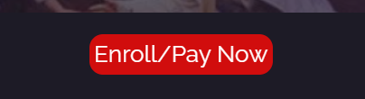
- Select ‘Book Now’
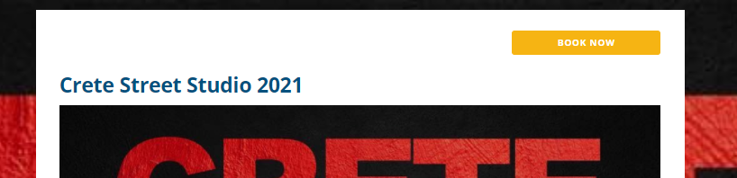
- Select how many streams and how long you’re enrolling/paying for then click ‘next’
Ignore the Tuesday 12 January date as this is ONLY for Trybooking purposes and does not reflect what you are purchasing.
In the below example, 1 Stream for 1 Year is selected.
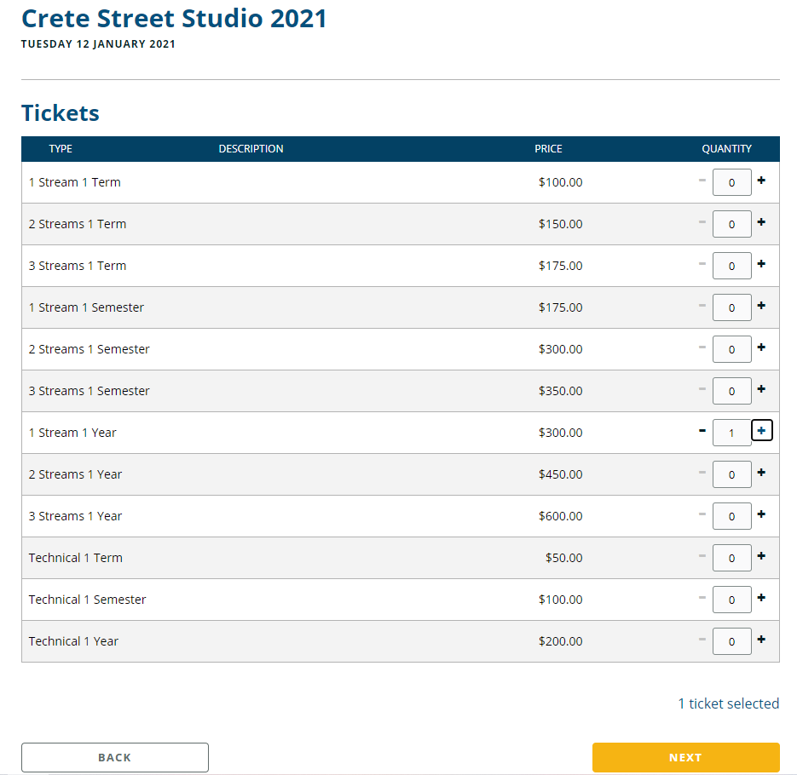
- Fill out student information
If you select more than 1 ticket on the previous page, you will have to fill out the below for each ‘ticket’. This option works for if you are enrolling multiple students at once. Please ensure ALL information is correct as this is what we will use to contact you and for current COVID-19 Contact Tracing purposes.
- Select Classes and fill out special information, the click ‘next’
This is on the same page as step 5. Please ensure you have looked at the timetable before selecting classes. Class names are listed on the timetable to ensure you select the correct one. Only select classes you are paying for. For example, if you have selected 2 streams, you should be selecting 2 classes.
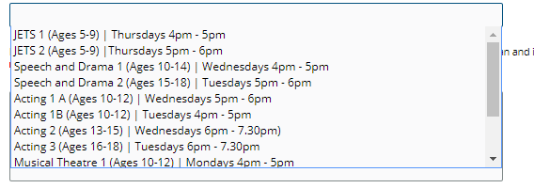
- Fill out payment details and click ‘purchase’
Please use the STUDENT NAME in the booking details name section. This makes it easier for us to locate your booking if required. You will then see a booking confirmation page. Your ‘ticket’ information will also be emailed to you. You should then receive an email from us in a couple of days confirming your enrollment and class selection.
